Switch on 2470 AUSHON.
Switch on Mac computer. Do not connect to WiFi.
Remove WP384 plates from UF. Let them thaw while rocking.
Remove Oncyte slides from the refrigerator. Place them on the platens (10 slides per platen, 5 platens).
When lysates have thawn in the WP384 plates, remove sealing films and place lids; put the lided WP384 plates in the carrier plates. The left side (where the barcode sticker is) should be on the opposite side than the one labelled as (THIS END OUT). Load the carrier plates in the 2470 AUSHON.
Place platens with the Oncyte slides in the 2470 AUSHON.
Verify that there is sufficient amount of ultrapure water in the clean wash fluid carboy, and that the waste fluid carboy is empty. For 15 WP384 plates and 50 slides, the operation takes ~29 hours; this means that water reload and waste water emptying is required at least once, approximately after 18 hours. Also, make sure that there is ultrapure water in the humidifier.
In the Mac, click on the Aushon arrayer image. Login with your credentials.
Enter the following parameters (see next four pages):

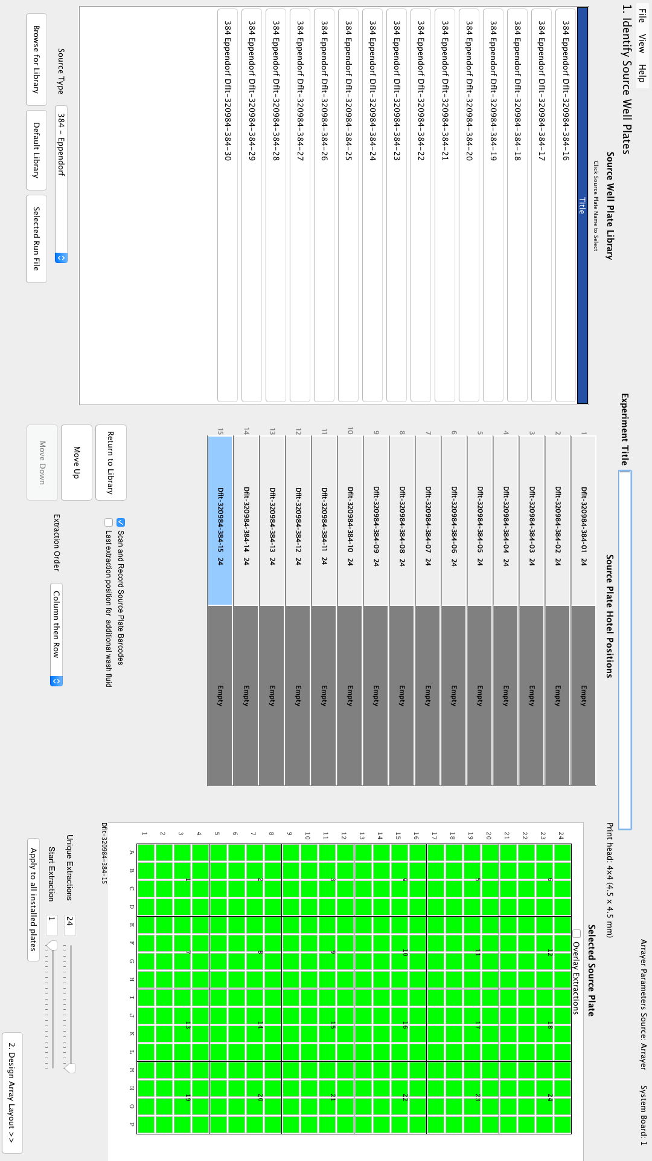
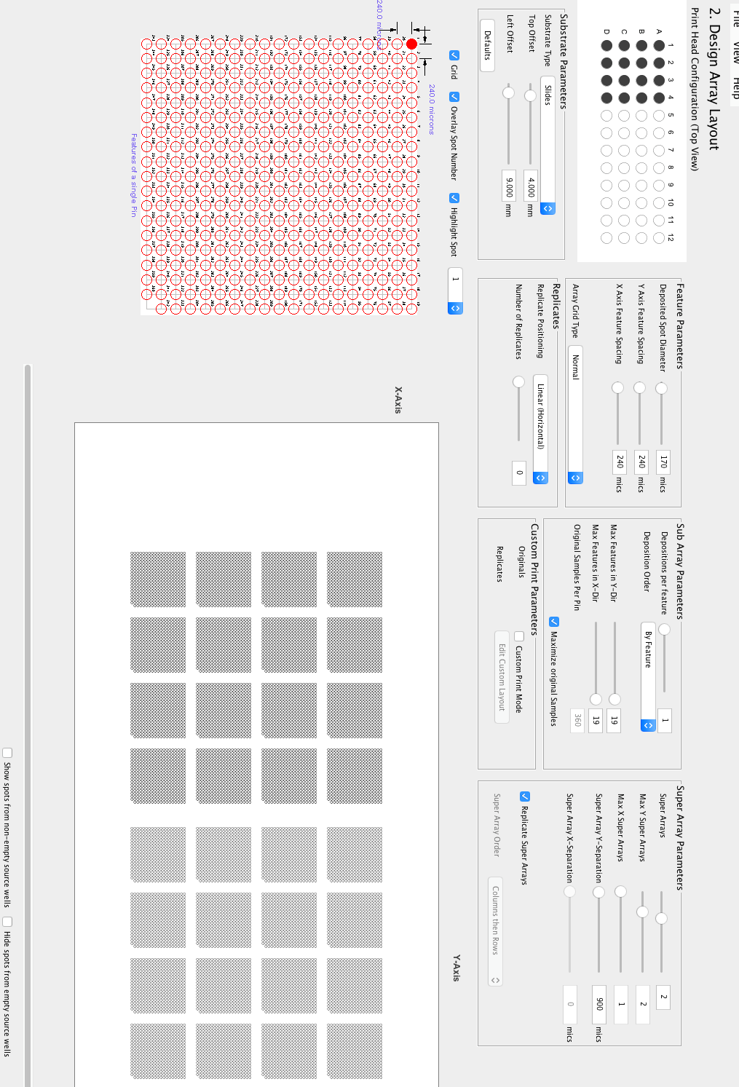

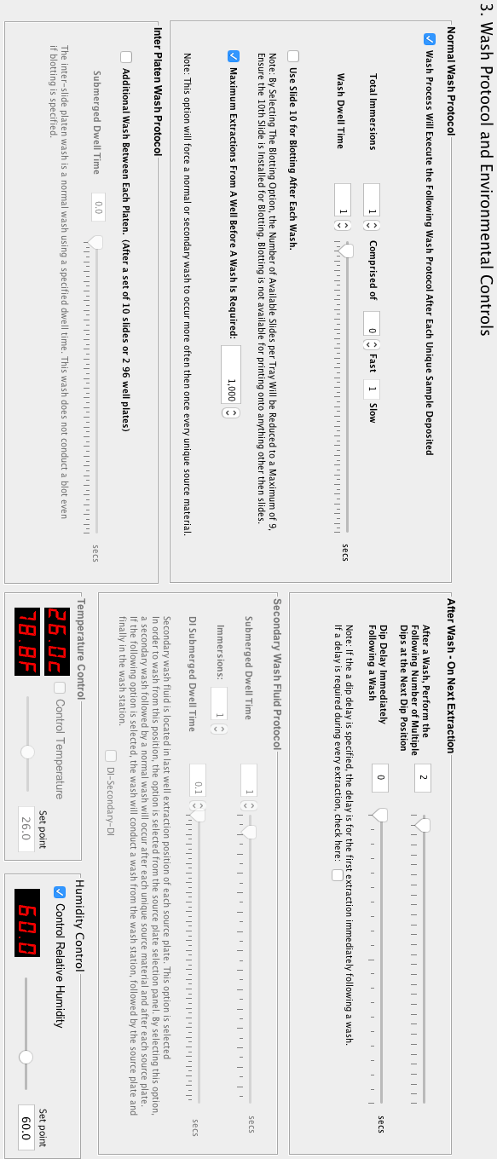
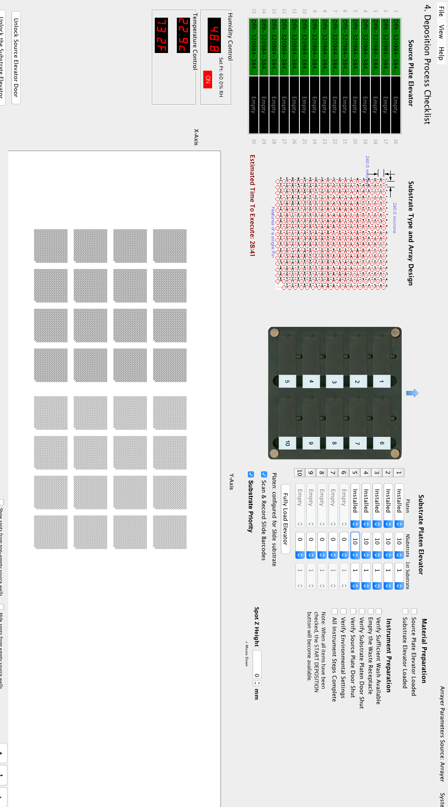
Tick all “Material Preparation” and “Instrument Preparation”. The “START DEPOSITION” button becomes active. Click on it. Wait for any error or attention messages (open doors, etc).
At the end of the spotting run (i.e. 29 hours later), retrieve WP384 plates from the carrier plates. Scan their barcodes if needed (see below, in case that they were scanned incorrectly). Remove and retain lids. Place new sealing film for each WP384 plate. Return sealed WP384 plates to their positions in UF. Remove Oncyte slides from the platens. Take care not to touch the nitrocellulose membranes. Scan their barcodes if needed (see below, in case that they were scanned incorrectly). Place slides in a green box.
Make sure that slide- and WP384 plate- barcodes have been scanned correctly (check excel and log pdf output in Mac, automatically displayed after the spotting run); if not, incorrectly scanned barcodes will appear as “NR,Rþeó”, and incorrectly scanned well plate barcodes will appear as either “NR” or “Rþeó NR” in the gal file. If any of them have been scanned incorrectly you need to input the correct barcodes manually in the gal file. In this case, rename the gal file extension to txt, open the file with a txt editor and input the slide barcodes as explained below; DO NOT insert spaces after commas; leave no space after the last slide but just newline (enter):
Incorrect:
SlideBarcode=GBL 9115064, GBL 9115061, GBL 9114509, GBL 9114512
BlockCount=32

Correct:
SlideBarcode=GBL 9115064,GBL 9115061,GBL 9114509,GBL 9114512
BlockCount=32

Save the file. Remove the .txt extension and rename so that the prefix will be the print date in YYYYMMDD format. Upload the gal file in LIBRA (IMPORT SLIDES FROM GAL files).

